How to create an Express Server?

* Create a Folder.
* Open Terminal in that folder Or Right Click on Folder you just created and click "Open with Code".
* Press Ctrl + ` to toggle Terminal.
* Run Command "npm init --y" to initialize a Nodejs App.

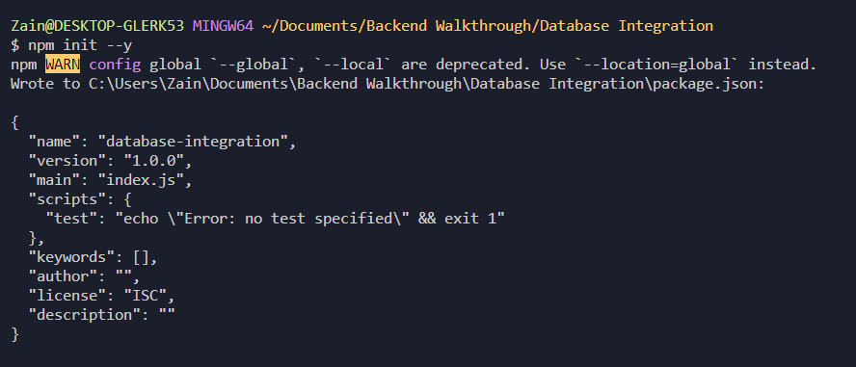

* Now we need to install “express” (server) package to create our API's and “nodemon” package so that it restarts our app every time we make some changes in it.

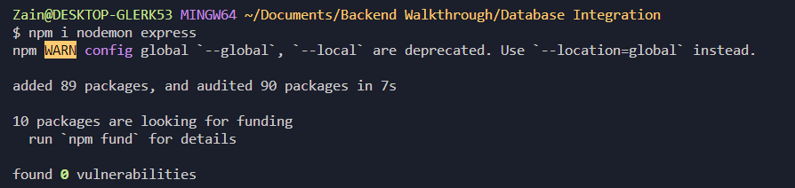

* After successful install create a JavaScript file "server.js" or "index.js". Any filename you want.



* Now import express package.

const express = require("express"); *// import express*

* Create Express App By:

const app = express(); *// create an express app.*

* Declare some Unique Number as Port where the server will run and add a listen function where our express server will listen to:

const PORT = 5000; *// You can assign Unique Port you want.*

app.listen(PORT, () => {

console.log(`Listening on PORT: ${PORT}`);

}); *// Express App Listen Function use to start server at some port.*

* Now we will create Some Routes for our app.

1. “/” the home Route

app.get("/", (request, response) => {

*return* response.json("Hello World");

});

1. “/users” to demonstrate data response.

app.get("/users", (request, response) => {

let users = [

{

id: "1",

name: "Ali",

age: 18,

message: "Hello This is Some Data over GET Request",

},

];

*return* response.json(users);

});

* Now let’s Test Our Express App.
* In terminal Run nodemon server.js OR node server.js
* Install Postman from <https://www.postman.com/downloads/?utm_source=postman-home>

Or you can open Browser at <http://localhost:5000>.

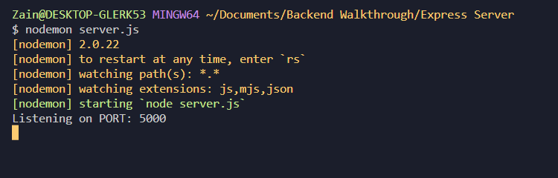

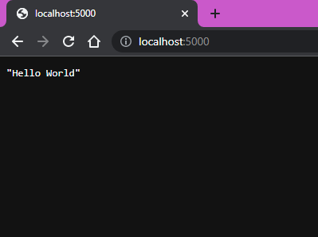

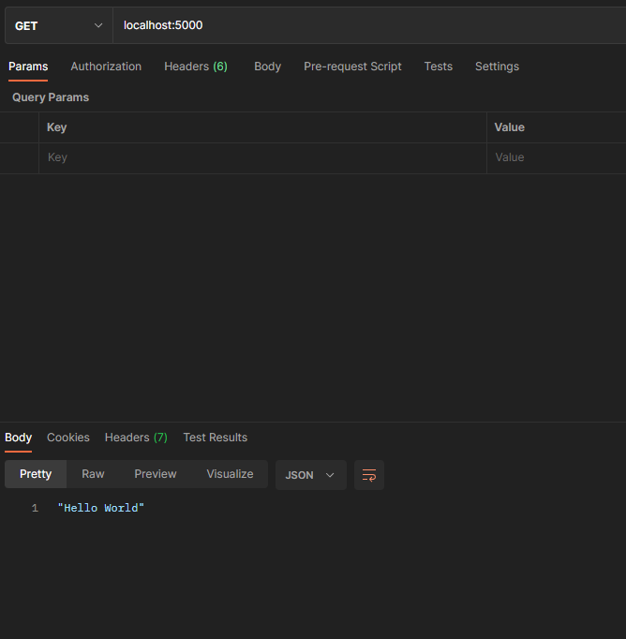

* Great! Now we will to check our 2nd Route.

